**MOwNiT – laboratorium**

**Rozwiązywanie równań różniczkowych zwyczajnych**

**Metoda Eulera**

|  |  |  |
| --- | --- | --- |
| Liczba punktów $n$ | Błąd maksymalny | Błąd średniokwadratowy |
| 10 | 3.203E+01 | 1.690E+01 |
| 50 | 1.626E+01 | 5.230E+00 |
| 100 | 1.083E+01 | 3.491E+00 |
| 200 | 6.398E+00 | 2.067E+00 |
| 300 | 4.529E+00 | 1.464E+00 |
| 400 | 3.504E+00 | 1.133E+00 |
| 500 | 2.857E+00 | 9.241E-01 |
| 600 | 2.411E+00 | 7.801E-01 |
| 700 | 2.086E+00 | 6.749E-01 |
| 800 | 1.838E+00 | 5.947E-01 |
| 900 | 1.642E+00 | 5.315E-01 |
| 1000 | 1.485E+00 | 4.804E-01 |
| 10000 | 1.538E-01 | 4.981E-02 |

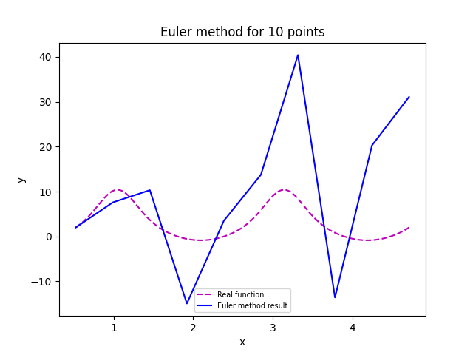

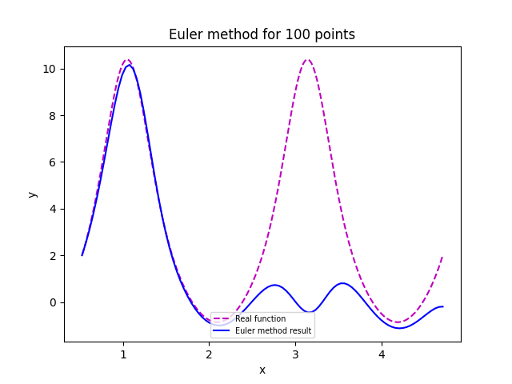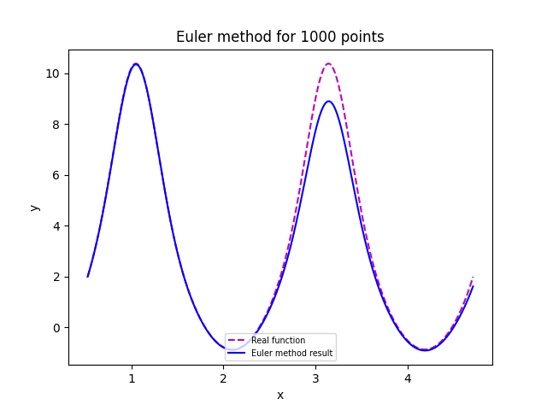

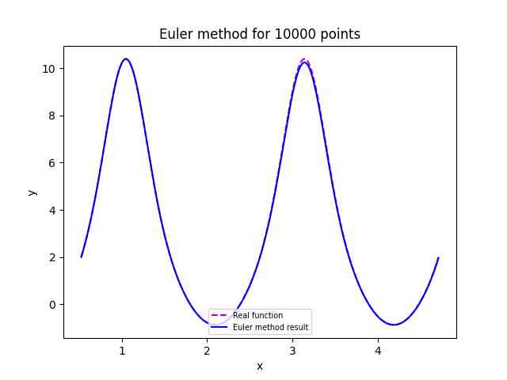

**Metoda Rungego-Kutty**

|  |  |  |  |
| --- | --- | --- | --- |
| Liczba punktów $n$ | $$r$$ | Błąd maksymalny | Błąd średniokwadratowy |
| 10 | 1 | 3.203E+01 | 1.690E+01 |
| 20 | 1 | 2.083E+01 | 6.836E+00 |
| 30 | 1 | 1.921E+01 | 6.352E+00 |
| 50 | 1 | 1.626E+01 | 5.230E+00 |
| 100 | 1 | 1.083E+01 | 3.491E+00 |
| 10 | 1 | 1.887E+02 | 8.781E+01 |
| 20 | 2 | 5.456E+00 | 1.706E+00 |
| 30 | 2 | 1.902E+00 | 5.900E-01 |
| 50 | 2 | 3.744E-01 | 1.195E-01 |
| 100 | 2 | 3.563E-02 | 1.425E-02 |
| 10 | 3 | 1.664E+03 | 6.017E+02 |
| 20 | 3 | 1.164E+01 | 3.676E+00 |
| 30 | 3 | 3.749E+00 | 1.213E+00 |
| 50 | 3 | 7.053E-01 | 2.403E-01 |
| 100 | 3 | 5.665E-02 | 2.511E-02 |
| 10 | 4 | 3.761E+00 | 1.755E+00 |
| 20 | 4 | 1.307E-01 | 5.481E-02 |
| 30 | 4 | 2.133E-02 | 8.389E-03 |
| 50 | 4 | 3.261E-03 | 1.079E-03 |
| 100 | 4 | 2.232E-04 | 8.414E-05 |

